C4_2

setwd(".")  
library(knitr)

#Apartado A

interval<-0.01  
x<-seq(from=-1,to=2,by=interval)  
f_X<-function(x1){  
 f<-rep(0,length(x1))  
 for(i in 1:length(x1)) {  
 if((x1[i]<=0)|(x1[i]>=1)) {  
 fX=0  
 } else {  
 fX=5*((1-x1[i])*(1-x1[i])*(1-x1[i])*(1-x1[i]))  
 }  
 f[i]=fX   
 }  
 return(f)  
}  
plot(x,f_X(x), col="blue", type="l", lwd = 3,  
 ylab = "función de densidad f(x)")  
grid()  
min(f_X(x))

## [1] 0

prob_1<-integrate(f_X,-1,2)  
prob_1

## 1 with absolute error < 6.6e-05

#Apartado B  
x_1 <- 0  
x_2 <- 0.1  
p <- f_X(seq(x_1,x_2,interval))  
z <- c(x_1,seq(x_1,x_2,interval),x_2)  
p <- c(0,p,0)  
polygon(z,p,col = "red")

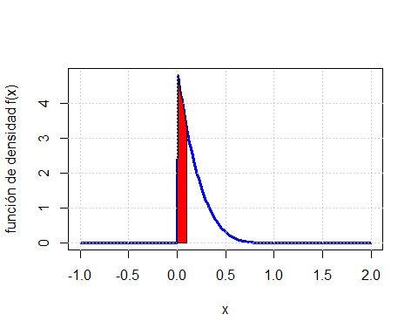

integrate(f_X,x_1,x_2)

## 0.40951 with absolute error < 4.5e-15

# Apartado C  
  
plot(x,f_X(x), col="blue", type="l", lwd = 3,  
 ylab = "Función de densidad f(x)")  
grid()  
x_3 <- 0.5  
x_4 <- 1  
p <- f_X(seq(x_3,x_4,interval))  
z <- c(x_3,seq(x_3,x_4,interval),x_4)  
p <- c(0,p,0)  
polygon(z,p,col = "yellow")

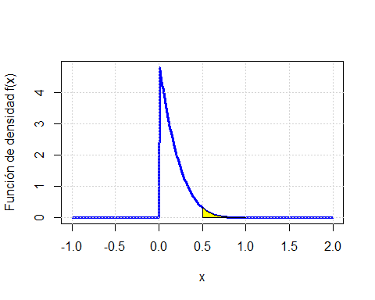

integrate(f_X,x_3,x_4)

## 0.03125 with absolute error < 3.5e-16